Supplementary
- Process constraints of case 3

Nomenclature
$T$ temperature
$n_{j}$ the molecule structure of refrigerant used in the $j^{th}$ stage
$T_{j,1}$ evaporating temperature in the $j^{th}$ stage
$T_{j,2}$ compressor outlet temperature in the $j^{th}$ stage
$T_{j,3}$ condensing temperature in the $j^{th}$ stage
$P_{j,1}$ evaporating pressure in the $j^{th}$ stage
$P_{j,2}$ compressor outlet pressure in the $j^{th}$ stage
$P_{j,3}$ condensing pressure in the $j^{th}$ stage
$T_{j,1}$ evaporating temperature in the $j^{th}$ stage
$T_{j,2}$ compressor outlet temperature in the $j^{th}$ stage
$T_{j,3}$ condensing temperature in the $j^{th}$ stage
$h_{j,1}$ compressor inlet enthalpy in the $j^{th}$ stage
$h_{j,2}$ compressor outlet enthalpy in the $j^{th}$ stage
$h_{j,3}$ condenser outlet enthalpy in the $j^{th}$ stage
$s_{j,1}$ compressor inlet entropy in the $j^{th}$ stage
$s_{j,2}$ compressor outlet entropy in the $j^{th}$ stage
$Z$ compressibility factor
$φ$ fugacity coefficient
$COP$ Coefficient of performance
$Q_{j}$ the flow rate in the $j^{th}$ stage
$T_{0}$ reference temperature
$T_{cw}$ the temperature of the cooling medium
$∆T_{cw}$ the temperature difference in the heat exchanger of the condenser
$T_{ambient}$ the temperature of ambient environment
$∆T_{ambient}$ the temperature difference in heat exchanger of evaporator
$∆T_{inter}$ the temperature difference in condensing evaporator
$T_{b}$ boiling point
$T_{c}$ critical temperature
$P_{c}$ critical pressure
$CYCLE$ Unit Refrigeration Cycle Model
1-4 Process points of refrigeration cycle
Cascade refrigeration system is the series connection of multiple single-stage refrigeration systems. Fig. 1 shows the structure of a single-stage vapor compression refrigeration system. Single-stage refrigeration system is composed of four components: the evaporator, compressor, condenser, and expansion valve. The refrigerant flows between these components through pipes, changing in pressure and temperature throughout the cycle. In the evaporator, the refrigerant absorbs heat from the ambient environment and evaporates, becoming a low-temperature, low-pressure saturated vapor (point 1 in the figure). This vapor then enters the compressor, where it is compressed into a high-temperature, high-pressure superheated vapor (point 2 in the figure). Next, the superheated vapor moves into the condenser, where it transfers heat to the cooling medium and condenses into a high-temperature, high-pressure liquid (point 3 in the figure). The high-temperature, high-pressure liquid then passes through the expansion valve, where it expands and becomes a low-temperature, low-pressure vapor-liquid mixture (point 4 in the figure). Finally, this mixture re-enters the evaporator, absorbs heat from the environment, and evaporates, thus completing the cycle. Through this continuous process, the vapor compression refrigeration system absorbs heat from the environment and transfers it to the cooling medium.
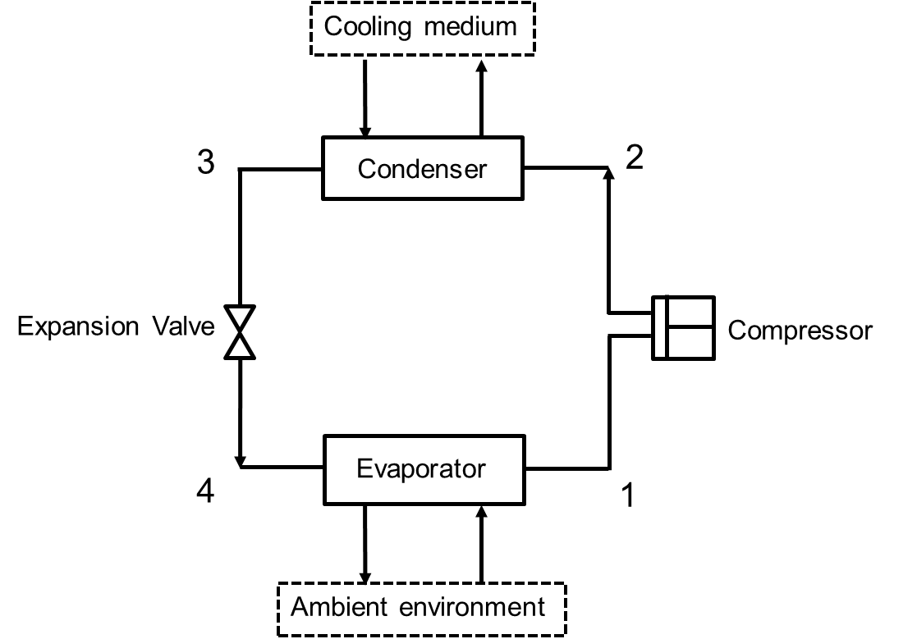
Fig. 1 The Structure of single-stage refrigeration

Fig. 2 illustrates the structure of an m-stage cascade refrigeration system, which consists of m single-stage refrigeration cycles. The evaporator of the $j$^{th} stage and the condenser of the $(j+1)$^{th} stage share a component called the condensing evaporator. Each stage uses a single refrigerant, resulting in a total of m refrigerants in the system. The refrigerant in the $j$^{th} stage evaporates in its evaporator to absorb heat released from the condenser of the $(j+1)$^{th} stage and transfers this heat to the $(j-1)$^{th} refrigerant through the condensing evaporator. The m^{th} refrigerant absorbs heat from the ambient environment in the evaporator of the $m$^{th} stage. In the condenser of the first stage, the refrigerant transfers heat to the cooling medium, thereby completing the m-stage cascade refrigeration process. Compared to single-stage refrigeration, cascade refrigeration can achieve lower temperatures due to the flexible use of different refrigerants, with the $(j-1)$^{th} stage acting as the cooling device for the $j$^{th} stage.
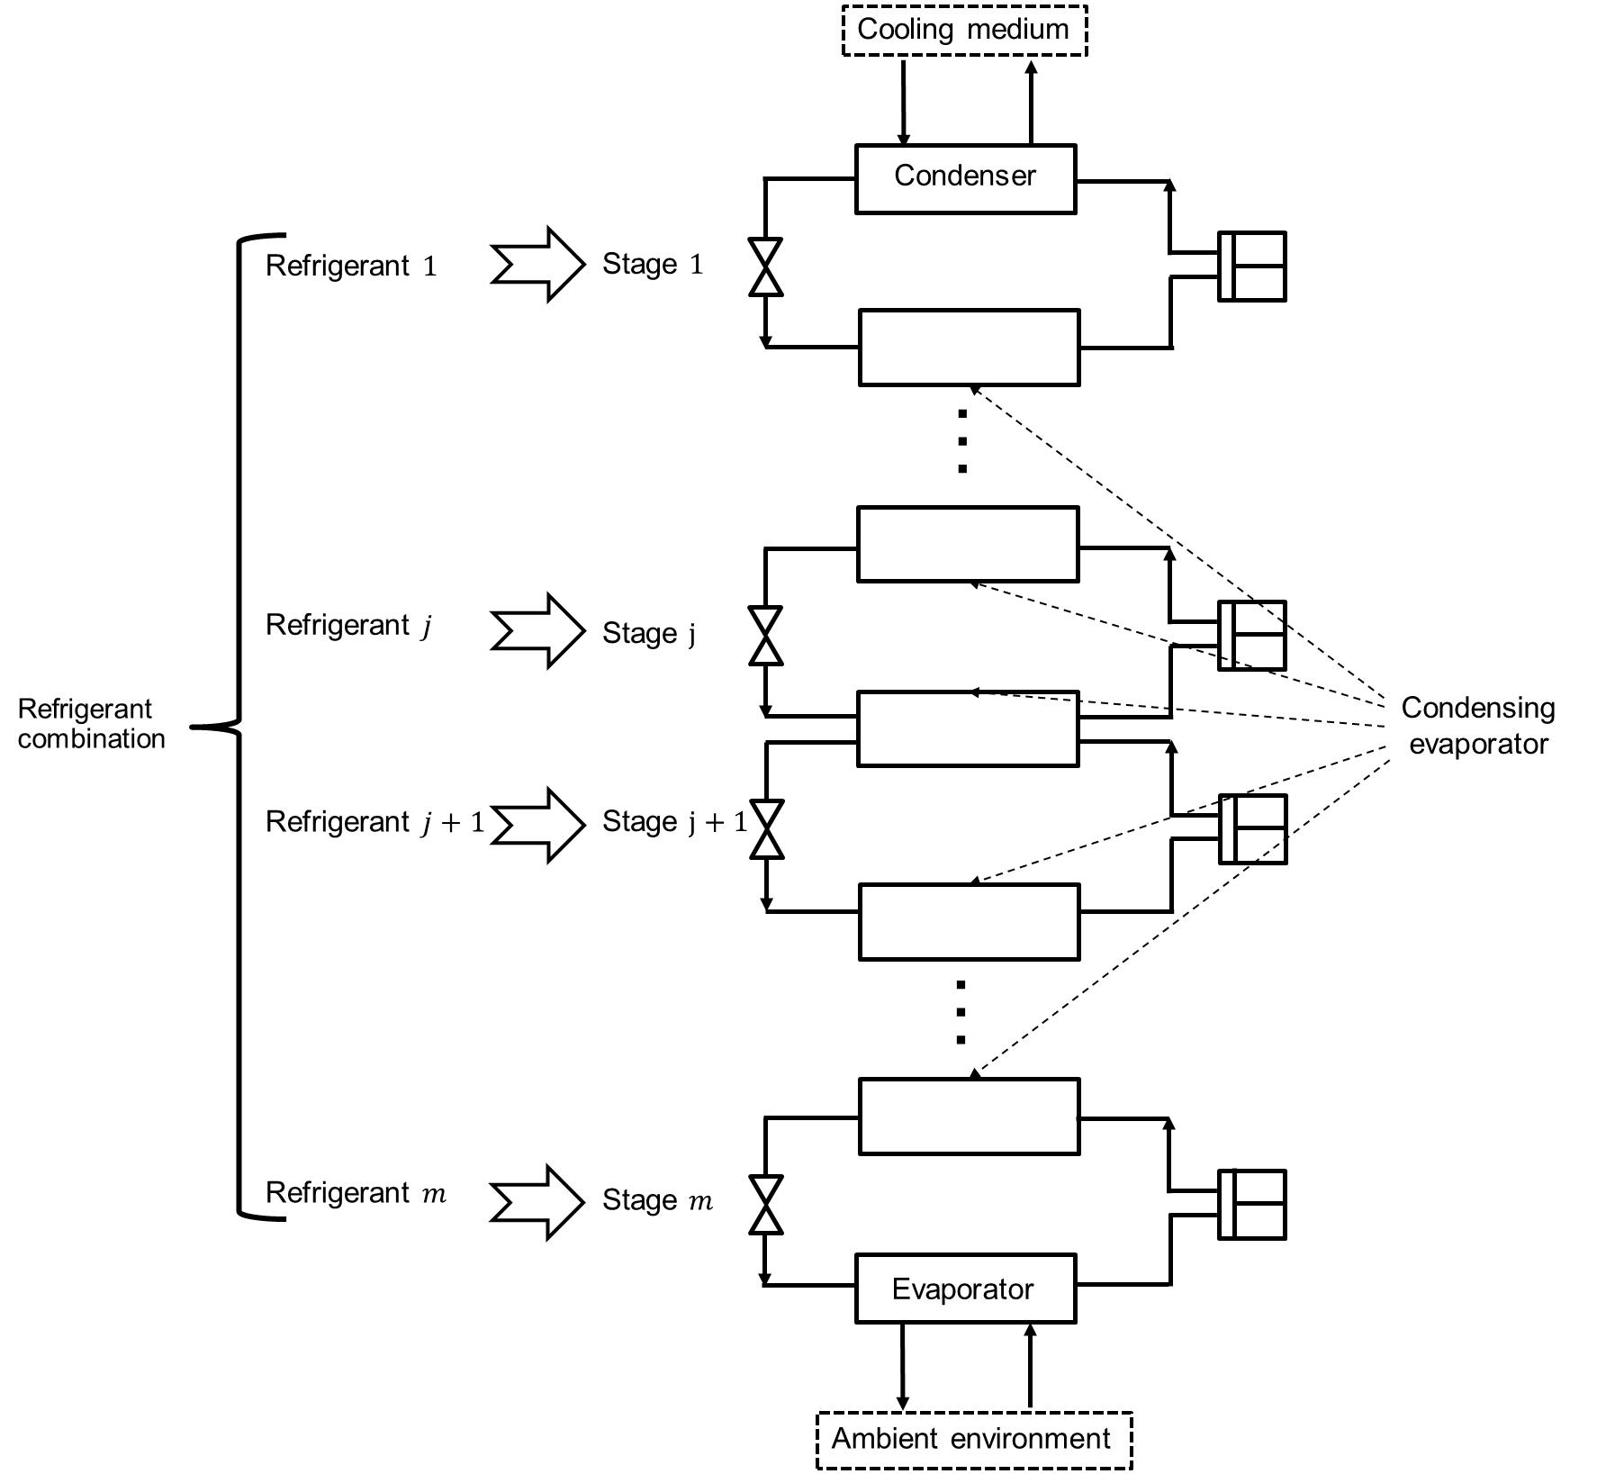
Fig. 2 The structure of m-stage cascade refrigeration

The process model is described as follows: In Eq. (1), $j$ represents the stage and $m$ represents the total number of stages. 1 represents the highest-temperature stage and $m$ represents the lowest-temperature stage. The second number represents the point in the cycle (1,2,3,4). So $h_{j,i}$ indicates the enthalpy of the refrigerant at point $i$ in the $j$th stage. Here,$h_{m1}-h_{m3}$ represents the heat absorbed from the environment by the refrigerant in the evaporator at the lowest temperature. The term $\sum_{1}^{m}{{(h}_{j2}-h_{j1})}$ represents the total work done by the compressors across all stages. The coefficient of performance (COP) for a cascade refrigeration system, which is a key performance indicator, is defined as the ratio of the heat absorbed from the environment to the total work done by the compressors. Therefore, COP is selected as the objective function:
$COP=\frac{Q_{m}(h_{m,1}-h_{m,3})}{\sum_{1}^{m}{{Q_{j}(h}_{j,2}-h_{j,1})}}$ (1)
Eqs. (2)-(5) are used to calculate the process variables at each point $i=1,2,3,4$ in a single refrigeration cycle. Here, $T_{0}$ and $P_{0}$ represent the reference temperature and pressure, set to 273.15 K and 1 atm in this study. At each point, the pressure P, temperature T and compressibility factor Z are calculated through the SRK equation of state.
$f\left(Z\right)=0=Z^{3}-Z^{2}+Z\left(ΨR\frac{{T_{c}}^{2}P}{T^{2}P_{c}}α-Ω\frac{T_{c}P}{P_{c}T}-{\left(Ω\frac{T_{c}P}{P_{c}T}\right)}^{2}\right)-ΩΨR\frac{{T_{c}}^{3}P^{2}}{T^{3}{P_{c}}^{2}}α$ (2)
$α={(1+κ(1-\sqrt{\frac{T}{T_{c}}}))}^{2}$ (3)
$κ=0.480+1.574ω-0.176ω^{2}$ (4)
Here, the Pitzer's Acentric factor ω is calculated through Lee and Kessler method, shown as follows,
$ω = \frac{-log\left(P_{c}*0.98692327*1e-5\right)- 5.92714 +\frac{6.09648}{\frac{T_{b}}{T_{c}}}+ 1.28862*log\left(\frac{T_{b}}{T_{c}}\right)- 0.169347*{\left(\frac{T_{b}}{T_{c}}\right)}^{6}}{ 15.2518 - \frac{15.6875}{\frac{T_{b}}{T_{c}}} - 13.4721*\log\left(\frac{T_{b}}{T_{c}}\right)+ 0.43577*{\left(\frac{T_{b}}{T_{c}}\right)}^{6}}$ (5)
For the equation-based selection of the correct liquid and vapor phase compressibility factor roots, the following constraints are employed:
$$f\left({Z_{v}}_{1}\right)=0$$
$$f^{'}\left({Z_{v}}_{1}\right)≥0$$
$$f^{''}\left({Z_{v}}_{1}\right)≥0$$
$$f\left({Z_{v}}_{2}\right)=0$$
$$f^{'}\left({Z_{v}}_{2}\right)≥0$$
$$f^{''}\left({Z_{v}}_{2}\right)≥0$$
$$f\left({Z_{l}}_{3}\right)=0$$
$$f^{'}\left({Z_{l}}_{3}\right)≥0$$
$$f^{''}\left({Z_{l}}_{3}\right)≤0$$
Consequently, the enthalpy h is calculated considering the equilibrium constraints of entropy s and fugacity coefficient φ.
$h=h_{0}+\int_{T_{0}}^{T}{{Cp}_{ig}(T)}dT+RT\left(Z-1\right)-\frac{ΨR}{Ω}(\sqrt{αTT_{c}}κ+αT_{c})ln⁡(\frac{Z+Ω\frac{T_{c}P}{P_{c}T}}{Z})$ (6)
$s=s_{0}+\int_{T_{0}}^{T}{\frac{{Cp}_{ig}(T)}{T}}dT-R(\ln\left(\frac{P}{P_{0}}\right)+\ln\left(Z-Ω\frac{T_{c}P}{P_{c}T}\right)-\frac{Ψ\sqrt{αT_{c}}κ}{Ω\sqrt{T}})ln⁡(\frac{Z+Ω\frac{T_{c}P}{P_{c}T}}{Z})$ (7)
$φ=e^{Z-1-\ln\left(Z-Ω\frac{T_{c}P}{P_{c}T}\right)-\frac{ΨRT_{c}}{ΩT}αln⁡(\frac{Z+Ω\frac{T_{c}P}{P_{c}T}}{Z})}$ (8)
$s_{1}=s_{2}$ (9)
${φ_{v}}_{1}={φ_{l}}_{1}$ (10)
${φ_{v}}_{3}={φ_{l}}_{3}$ (11)
Finally, here are some isobaric and isothermal constraints between these points:
$P_{2}=P_{3}$ (12)
$P_{1}=P_{4}$ (13) $T_{1}=T_{4}$ (14)
Eqs. (2)-(14) form the mechanism model for a single-refrigeration system. The free process variables are temperature at point 1 and 3, that is, the condensing temperature and evaporating temperature. For simplicity, these equations can be expressed as the Unit Refrigeration Cycle Model, shown in Eq. (15):
$[h_{1},h_{2},h_{3}]=CYCLE(T_{1},T_{3},MS(\vec{u})$ (15)
For a cascade refrigeration system, the structure and mechanism for each stage is the same as that of a single-stage refrigeration system. Therefore, the molecular structure constraints and process constraints for each stage can be directly expressed using Unit Refrigeration Cycle Model. For the $j$^{th} stage, it is defined in Eq. (16).
$[h_{j1},h_{j2},h_{j3}]=CYCLE(T_{j1},T_{j3},MS({\vec{u}}_{j}))$ (16)
The condensing evaporator between the $j$^{th} and $j+1$^{th} stages, serves as both the evaporator for the $j$^{th} stage and the condenser for the $j+1$^{th} stage. On one side of the heat exchange surface, the refrigerant liquid of the $j$^{th} stage is being evaporated at a temperature of $T_{j1}$. On the other side, the refrigerant vapor of the $j+1$^{th} stage is being condensed at a temperature of $T_{j+1,3}$. Therefore, Eq. (17) ensures that the evaporation temperature of the refrigerant liquid in the $j$^{th} stage must be lower than the condensation temperature of the refrigerant vapor in the $j+1$^{th} stage in the condensing evaporator. This way, the $j$^{th} refrigerant can absorb heat from the $j+1$^{th} refrigerant. $∆T_{inter}$ refers to the temperature difference for heat transfer in the condensing evaporator.
$T_{j+1,3}-∆T_{inter}≥T_{j1}$ (17)
Eq. (18) indicates that the condensing temperature of the highest-temperature stage needs to exceed the cooling medium temperature in order to enable heat transfer from the cascade refrigeration system to the cooling medium.
$T_{13}≥T_{cw}+∆T_{cw}$ (18)
Eq. (19) indicates that the condensing temperature of the refrigerant in each stage must be lower than its critical temperature.
$T_{j3}≤{T_{cn}}_{j}$ (19)
Eq. (20) indicates that the evaporating temperature in the lowest-temperature stage should be lower than the ambient temperature in order for the cascade refrigeration system to absorb heat from the environment efficiently.
$T_{m1}≤T_{ambient}-∆T_{ambient}$ (20)
Eq. (21) indicates that the boiling point of the refrigerant in the $j$^{th} stage must be lower than the condensing temperature in the $j+1$^{th} stage. Eq. (22) indicates that the boiling point of the refrigerant in the lowest-temperature stage must be lower than the ambient temperature.
${T_{bn}}_{j}≤T_{j+1,3}$ (21)
${T_{bn}}_{m}≤T_{ambient}$ (22)
In Eq. (23), $Q_{j}$ represents the flow rate in the $j^{th}$ stage. This constraint indicates that the heat absorbed by the $j^{th}$ stage should be equal to the heat released from the ${j+1}^{th}$ stage (ignoring the heat lost in the air) to maintain the heat balance.
$Q_{j+1}\left(h_{j+1,2}-h_{j+1,3}\right)=Q_{j}\left(h_{j,1}-h_{j,3}\right)$ (23)
Overall, the integrated molecule selection and process design model for cascade refrigeration can be defined as follows:
Max: $COP$
Subject to: $[h_{j1},h_{j2},h_{j3}]=CYCLE(T_{j1},T_{j3},{\vec{n}}_{j})$ $j=1,2,3……m$
$$COP=\frac{Q_{m}(h_{m,1}-h_{m,3})}{\sum_{1}^{m}{{Q_{j}(h}_{j,2}-h_{j,1})}}$$
$Q_{j+1}\left(h_{j+1,2}-h_{j+1,3}\right)=Q_{j}\left(h_{j,1}-h_{j,3}\right)$ $j=1,2,3……m-1$
$T_{j3}≤{T_{cn}}_{j}$ $j=1,2,3……m$
${T_{bn}}_{j}≤T_{j+1,3}$ $j=1,2,3……m-1$
$${T_{bn}}_{m}≤T_{ambient}$$
$T_{j+1,3}-∆T_{inter}≥T_{j1}$ $j=1,2,3……m-1$
$$T_{ambient}-∆T_{ambient}≥T_{m1}$$
$$T_{13}≥T_{cw}+∆T_{cw}$$
This is a Mixed-Integer Nonlinear Programming (MINLP) problem where the decision variables include the condensing temperature $T_{j3}$, evaporating temperature $T_{j1}$ and the structure of the refrigerant ${\vec{n}}_{j}$ for each stage.

- Model Decomposition-based optimization used in case 3
This MINLP problem is composed of 13 continuous variables ($T_{1},T_{2},T_{3},T_{4},P_{1},P_{2},P_{3},P_{4},{Z_{v}}_{1},{Z_{l}}_{1},{Z_{v}}_{2},{Z_{v}}_{3},{Z_{l}}_{3}$) and 33 discrete variables($u_{1}, u_{2},u_{3}……u_{33}$) in each stage. So, the direct optimization of this problem is very tough, especially when the number of candidate groups and refrigeration stages becomes larger. For this integrated refrigerant selection and process optimization problem in cascade refrigeration system, Xu et al.(Xu et al., 2023) have introduced an efficient optimization algorithm based on model decomposition which is capable to achieve high-speed searching and high-quality solutions. The basic idea of this algorithm is trying to find constraints which are not process-specific or try to transform some process-specific constraints as not process-specific. Then, use these special constraints as sub-model 1 and other remaining constraints as sub-model 2. Only the feasible solution of sub-model 1 can be put into sub-model 2 to do the process optimization. Based on this model decomposition, the frequency of the nonconvex process optimization can be much reduced so that the efficiency of the optimization can be improved significantly. In the original model established above, Eq. (22) is not process-specific since it contains no any process variable. Eq. (19) and Eq. (21) contain process variables T, but the following constraint Eq. (24) which is not process-specific can be generated from them:
${T_{bn}}_{j}≤{T_{cn}}_{j+1},j=1,2,3……m-1$ (24)
In the same way, the following constraint Eq. (25) can be generated from Eq (18) and Eq (19):
$T_{cw}+∆T_{cw}≤{T_{cn}}_{1}$ (25)
This constraint is also not process-specific. Consequently, Eq. (22), (24) and (25) form sub-model 1 and the remaining constraints in the original model form sub-model 2, as shown in Fig. 3.
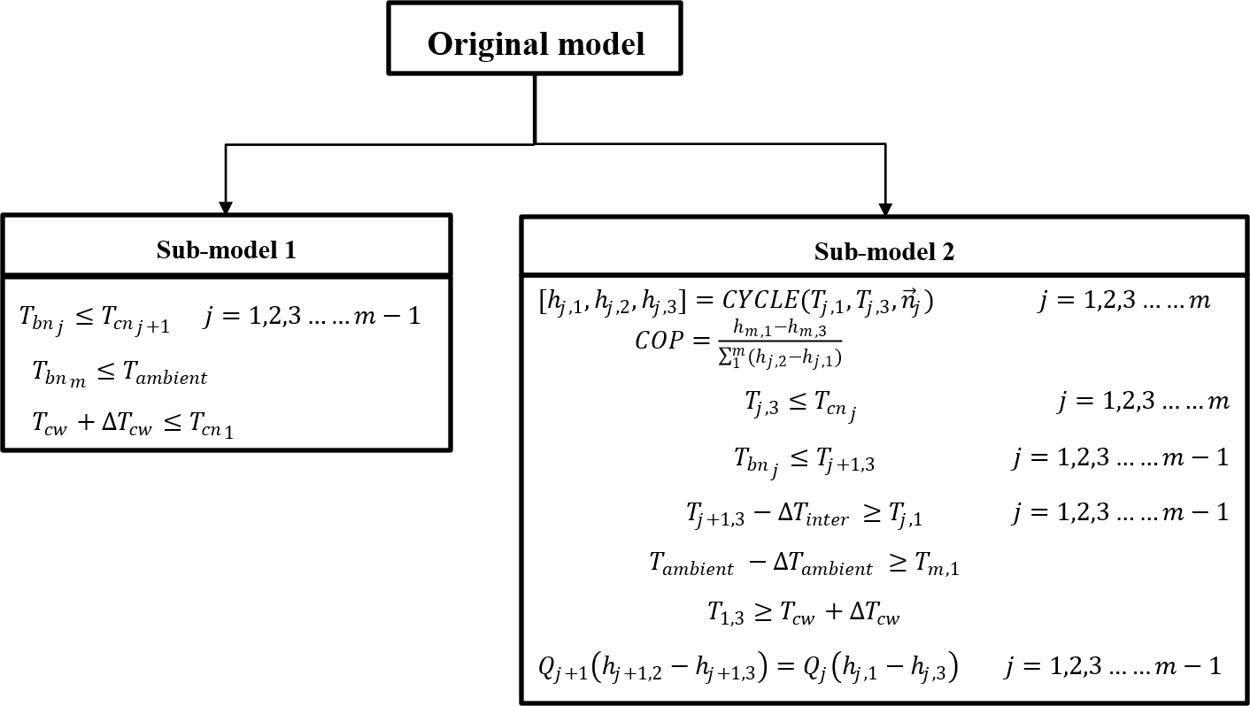
Fig. 3 Model decomposition-based optimization

Sub-model 1 is a IP problem and sub-model 2 is a NLP problem, which are much easier for solving than the original MINLP problem. Then, the optimization for sub-model1 and sub-model 2 is executed to achieve efficient optimization for the original model, enabling simultaneous optimization of the refrigerant molecular structure, condensing temperatures, and evaporating temperatures across all stages of the cascade refrigeration system.

